LAB EXPERIMENT RECORD
SET 6: PRODUCT SALES ANALYSIS
Department | AIDS
Course Code / Course Name | DSA0601 / Data Handling and Visualization
Experiment | Data Visualization using R
Name | B. Pallavi
Register Number | 192424243
Date | 01 October 2026
Day | Thrusday

Aim
To visualize monthly product sales data using a grouped bar chart, stacked area chart, and sales table, and to build an interactive dashboard using R and Tableau.
Dataset: Monthly Product Sales
Product ID | Product Name | January Sales | February Sales | March Sales

1 | Product A | 2000 | 2200 | 2400

2 | Product B | 1500 | 1800 | 1600

3 | Product C | 1200 | 1400 | 1100

PROGRAM 1: GROUPED BAR CHART OF PRODUCT SALES
# Dataset
product <- c("Product A", "Product B", "Product C")
sales <- matrix(c(2000, 2200, 2400,
1500, 1800, 1600,
1200, 1400, 1100),
nrow = 3, byrow = TRUE)
colnames(sales) <- c("January", "February", "March")
rownames(sales) <- product

# Grouped Bar Chart
bar_pos <- barplot(t(sales),
beside = TRUE,
names.arg = product,
xlab = "Product",
ylab = "Sales",
main = "Product Sales for First Quarter",
col = c("skyblue", "lightgreen", "orange"),
legend.text = TRUE,
args.legend = list(title = "Month"))
# Add sales labels
text(bar_pos,
t(sales),
labels = t(sales),
pos = 3,
cex = 0.7)
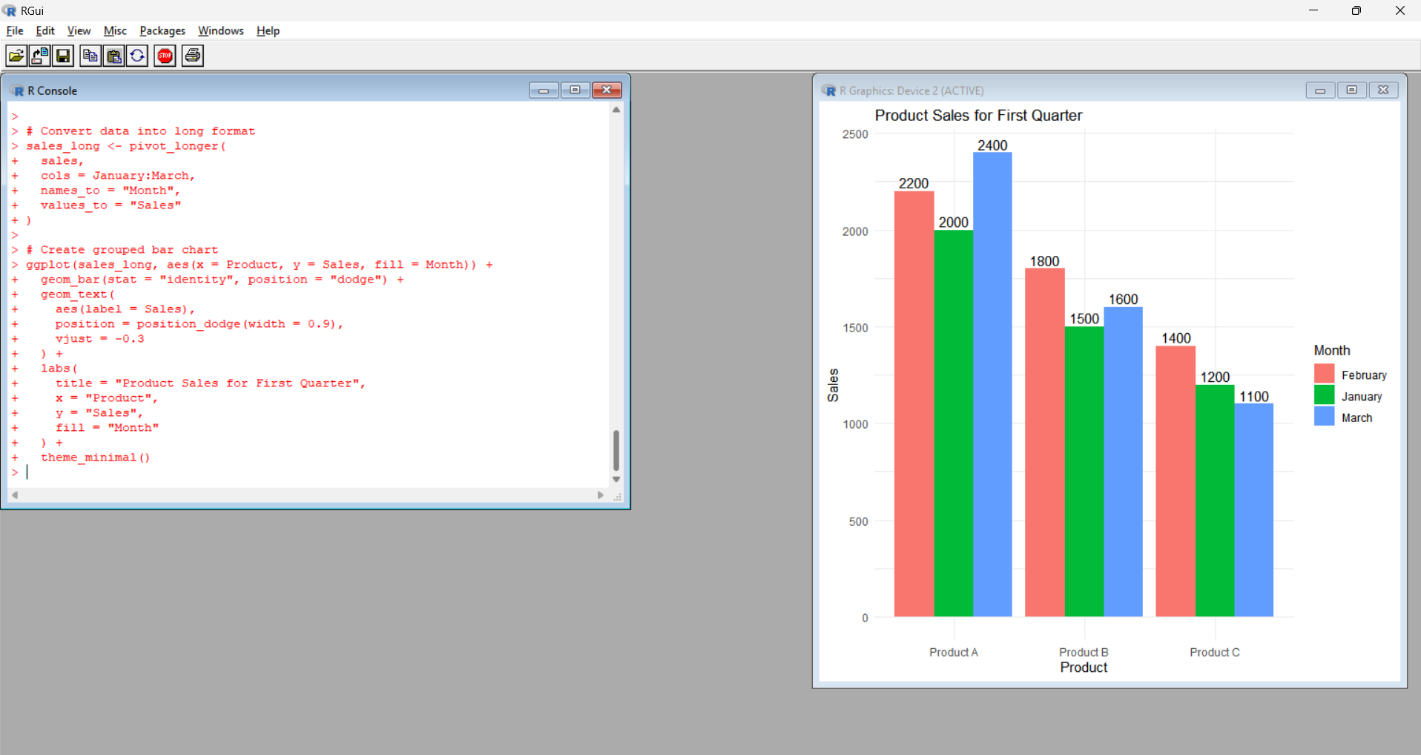
Output 1: Product Sales for First Quarter – Grouped Bar Chart

Observation: The grouped bar chart clearly compares the monthly sales of each product. Product A has the highest sales across the three months, while Product C has the lowest sales in March.
PROGRAM 2: STACKED AREA CHART OF OVERALL SALES TREND
# Dataset
months <- c("January", "February", "March")
sales <- matrix(c(2000, 1500, 1200,
2200, 1800, 1400,
2400, 1600, 1100),
nrow = 3, byrow = TRUE)
colnames(sales) <- c("Product A",
"Product B",
"Product C")
# Cumulative sales
cumulative <- t(apply(sales, 1, cumsum))
# Create empty plot
plot(1:3,
rowSums(sales),
type = "n",
xaxt = "n",
xlab = "Month",
ylab = "Sales",
main = "Overall Sales Trend",
ylim = c(0, max(rowSums(sales))))
# Add month labels
axis(1,
at = 1:3,
labels = months)
# Colors
area_col <- c("skyblue", "lightgreen", "orange")
# Create stacked areas
lower <- rep(0, 3)
for (i in 1:3) {
upper <- cumulative[, i]
polygon(c(1:3, rev(1:3)),
c(lower, rev(upper)),
col = area_col[i],
border = "black")
lower <- upper
}
# Add legend
legend("topleft",
legend = colnames(sales),
fill = area_col)
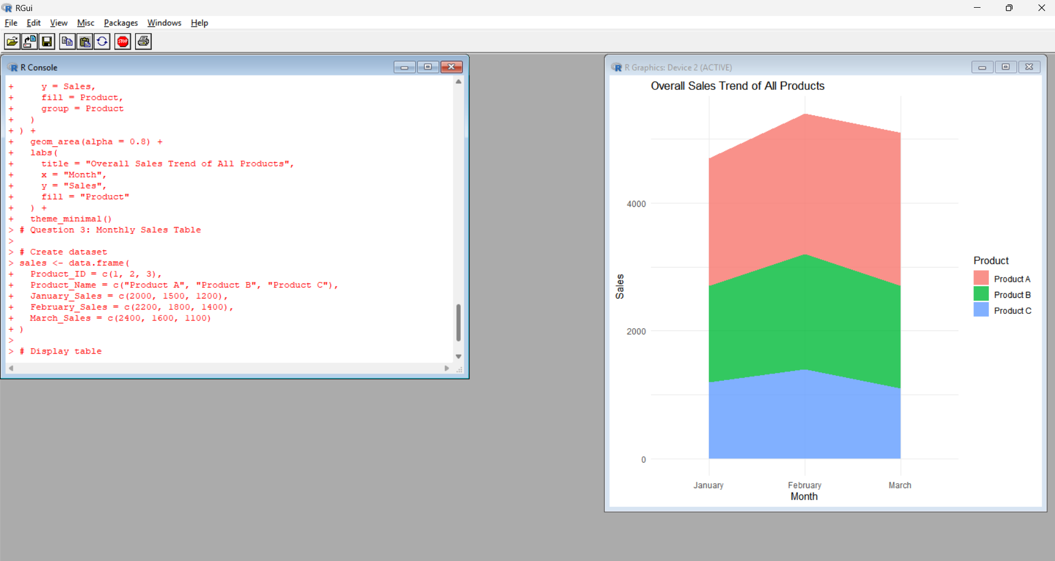
Output 2: Overall Sales Trend – Stacked Area Chart
Observation: The stacked area chart represents the contribution of each product to the overall monthly sales. The total sales are 4700 in January, 5400 in February, and 5100 in March. February has the highest overall sales.
PROGRAM 3: MONTHLY PRODUCT SALES TABLE
# Dataset
sales_data <- data.frame(
Product_ID = c(1, 2, 3),
Product_Name = c("Product A",
"Product B",
"Product C"),
January_Sales = c(2000, 1500, 1200),
February_Sales = c(2200, 1800, 1400),
March_Sales = c(2400, 1600, 1100)
)

# Display Sales Table
print(sales_data)
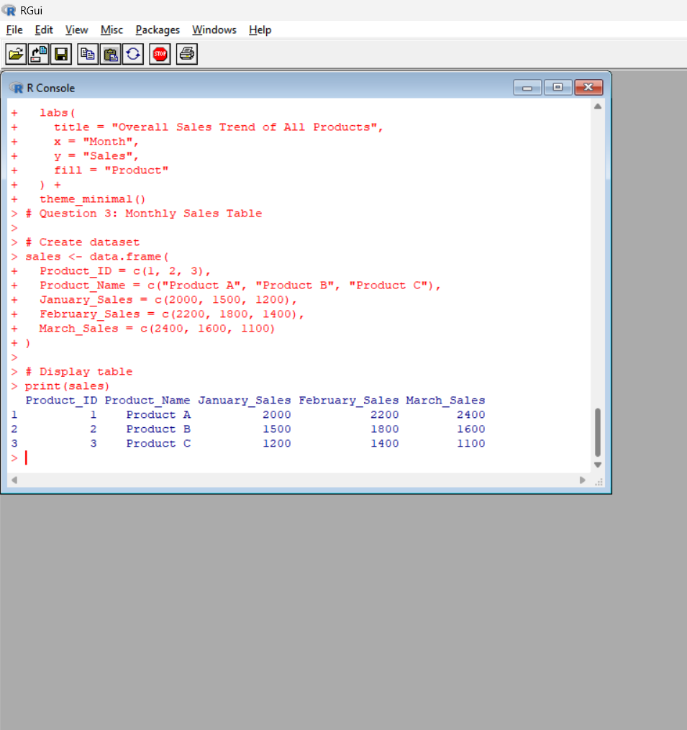
Output 3: Monthly Product Sales Table
Product ID | Product Name | January Sales | February Sales | March Sales
1 | Product A | 2000 | 2200 | 2400
2 | Product B | 1500 | 1800 | 1600
3 | Product C | 1200 | 1400 | 1100
Observation: The table clearly displays the monthly sales values for each product. Product A records the highest sales in all three months.
PROGRAM 4: INTERACTIVE PRODUCT SALES DASHBOARD
Prompt
Develop a Tableau dashboard combining grouped bar chart, stacked area chart, and table for interactive exploration.
Excel Dataset
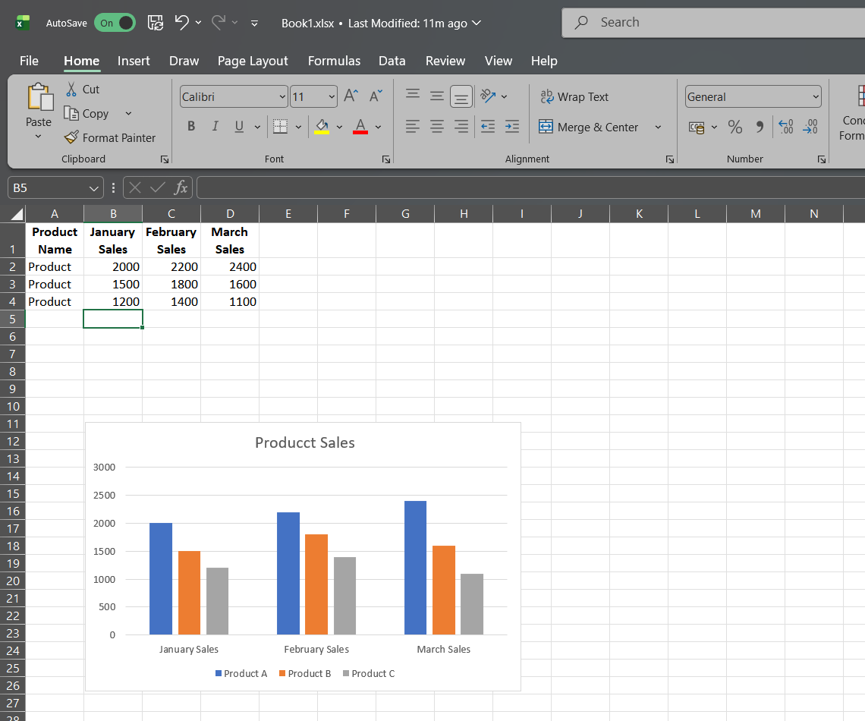
Create an Excel file with the following columns:
Product ID | Product Name | January Sales | February Sales | March Sales
1 | Product A | 2000 | 2200 | 2400
2 | Product B | 1500 | 1800 | 1600
3 | Product C | 1200 | 1400 | 1100

